Step 1
Describe the collected data analyzed within the report. Though the specifics of the data would be analyzed in the "Data" or "Analysis" section, a general statement about both the type of data gathered and the manner in which the data was gathered is important in your summary. For example, "The salary and housing report focuses on 1,182 survey responses from socioeconomically diverse households."
Step 2
Detail the criteria you used to evaluate the data. If you borrowed criteria or evaluative methods from other researchers, cite their contributions to your report. For example, "In accordance with Smith and Goldblatt's 1999 Study of Inmate Behavior, this report utilizes an adaptive behavior scale in its analysis of inmate testimony."
Step 3
List any and all results that seem to indicate trends. For example, "Upon evaluating the data, this report reveals that there is a correlative trend between an individual's educational background and the likelihood that they shop at Food Co."
Step 4
Explain any recommendations your trend analysis report will make in the conclusion section of the report. For example, "Upon identifying the trend connecting violent behavior with violent video games, this report will suggest a stricter video game ratings system for all future video game releases."

Writing about Graphs: Overview

Before you Begin
Underline key words. Write related words – turn nouns into verbs, verbs into nouns, adjectives into adverbs, etc. Write opposite words, similar words, synonyms, etc.
Circle and highlight the graph. Use arrows. Make notes. Circle the biggest, the smallest. stable or unchanging parts, sudden increases, etc.
Identify trends. A trend is the overall idea of the graph
- what is happening/what happened
- the main change over time
- the most noticeable thing about the graph
- the pattern over time
- the pattern for different places or groups or people.
Most IELTS graphs will have two trends, or there will be two graphs with a trend in each. You could write about the two trends in two separate paragraphs. Make sure you have identified the trends in the graph. If you don’t, you can’t get IELTS Band 6.

While you Write: Layout
Introduction
- First sentence: Describe the graph. You can use some slightly different words or word forms from those on the question paper, but be careful to give the full information. Start “The graph shows“
- Second sentence: This gives the trend or trends. You can put two trends in this sentence or only one – you could keep the other one for the conclusion. Start “Overall, …”
Paragraph 1: Trend 1
- Start with a sentence with no number. “City size increased sharply over the period.” “The most obvious trend in the graph is that women are having fewer babies.” “Oil production has increased slightly in all the countries in the graph”
- Follow this sentence with an example (sentence with number) and perhaps another example (another sentence with number). Keep alternating.
Paragraph 2: Trend 2
- Start with a sentence with no number. “City size increased sharply over the period.”
- Give an example (sentence with number) and perhaps another example (Sentence with number)
Conclusion
- Finish by repeating the main trends, or identify a second trend. Use different vocabulary.
- Don’t have any numbers in the conclusion (you could use words like “most”, “the majority” “a minority”, “a small number”).
- Don’t give an opinion.
While You Write: Some Don’ts
- Don’t describe the X and Y axis. Give the information.
- Don’t write about everything on the graph. Pick the biggest, the smallest, the main points, the main trends. Group similar things together
- Don’t write about the line or the bar: “The line went up,” “The bar went down.” Instead, write about the idea. “The number of people going to work by train increased gradually.” “Oil production shot up in 1965”
- Make sure you write about the idea. Don’t use shorthand: “Men went up.” “Women went down.” Instead, write about the real data: “The number of men at university fell dramatically,” “The percentage of female students getting a degree rose suddenly.”
- Don’t use “I feel”, “as I have written,” “as you can see,” etc. Keep it academic. In IELTS, you can give your opinions in Task 2. In Task 1 (writing about a graph or visual data) you just report what you see.
- Don’t start sentences with But, So, Also, And, For, Since, Because, Although
- Do you really need four paragraphs in IELTS Task 1? No! (You definitely need them for Task 2). But it’s good to think about four paragraphs. It will help you to organize your writing. So go ahead and write four paragraphs, or at least three (intro, body, conclusion).

Word Length and Sentence Length
Make sure you have 150 words. You should have some short sentences (about 6-10 words) and some long ones (12-18) words, but your average should be about 12 or 13 words per sentence.
A sentence without a number will usually be short. Use a mix – a sentence without a number followed by a sentence or two with a number.

Writing task one: single line graph

You will be given a graph with a single line. Your task is to write a 150 word report to describe the information given in the graph. You are not asked to give your opinion. You should spend around twenty minutes on the task. Task one is not worth as many marks as task two and so you should make sure that you keep within the recommended twenty minute time frame.

What is being tested is your ability to:
- objectively describe the information given to you
- report on a topic without the use of opinion
- use suitable language to describe the graph

Sample task

You should spend about 20 minutes on this task.
Write a report for a university lecturer describing the information in the graph below.
Write at least 150 words.
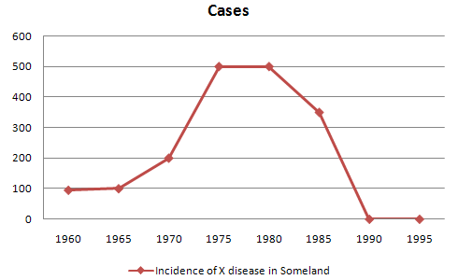
When you’ve finished the task
How good is your answer? Check the guidelines bellow and read the sample answer.

Guidelines for a good answer

Does the report have a suitable structure?
- Does it have an introduction, body and conclusion?
- Does it include connective words to make the writing cohesive within sentences and paragraphs?

Does the report use suitable grammar and vocabulary?
- Does it include a variety of sentence structures?
- Does it include a range of appropriate vocabulary?

Does the report meet the requirements of the task?
- Does it meet the word limit requirements?
- Does it describe the whole graph adequately?
- Does it focus on the important trends presented in the graphic information?

Sample answer

The graph shows the number of cases of X disease in Someland between the years 1960 and 1995. As an overall trend, it is clear that the number of cases of the disease increased fairly rapidly until the mid seventies, remained constant for around a decade at 500 cases before dropping to zero in the late 80s.
In 1960, the number of cases stood at approximately 100. That number rose steadily to 200 by 1969 and then more sharply to 500 in 1977. At this point the number of cases remained stable until 1984 before plummeting to zero by 1988. From 1988 to 1995 Someland was free of the disease.
In conclusion, the graph shows that the disease was increasingly prevalent until the 1980s when it was eradicated from Someland.
What do you think?
What is your opinion of this sample answer? How well does it meet the requirements of the guidelines? Read the teacher's comments on this answer.

Teacher's comments on the sample answer
“The report structure is easy to follow and logical with a clear introduction, body and conclusion. The candidate uses cohesive words to connect pieces of information and make the writing flow such as ‘until’ and ‘before’ in the second sentence. The candidate uses a variety of grammatical structures and vocabulary so that the writing is not repetitive.
In terms of task requirements the report is a little short but this is because the simple graph used as an example does not have sufficient information for the candidate to describe. In the real IELTS test the graph will have more information and so the need to look for trends will be even greater than in this example.”

Strategies for improving your IELTS score

Selecting information
It is important that you describe the whole graph fully. However, this does not mean that you should note every detail. In most cases there will be too much information for you to mention each figure. You will therefore need to summarise the graph by dividing it into its main parts. This is what we mean by describing the trends.
For example, in a chronological line graph it might seem sensible to describe the information year by year or period by period. The graph above gives the information in five year sections so we could write our report like this:
The number of cases of X disease started at 50 in 1965 and then went up gradually to 100 in 1965 and continued up to 200 in 1970 and then went up more sharply to 380 in 1975.
While this way of describing the information may be accurate, it does not meaningfully sum up the information in the graph. In fact, the information in the graph would most meaningfully be described in four chronological sections following the shape of the graph.

In the Sample Task, the graph shows four main trends:
- first, a gradual increase from 1960 to 1968
- second, a steeper increase from 1968 to 1977
- third, a plateau from 1977 to 1983
- fourth, a drop from 1983 to 1988
The structure of the report must show these four main trends clearly.
Report structure
Your report should be structured simply with an introduction, body and conclusion. Tenses should be used appropriately.
Introduction
Use two standard opening sentences to introduce your report. These opening sentences should make up the first paragraph. Sentence one should define what the graph is about; that is, the date, location, what is being described in the graph etc. For example:
The graph shows the number of cases of X disease in Someland between the years 1960 and 1995 …
Notice the tense used. Even though it describes information from the past, the graph shows the information in the present time.
Notice that the sample opening sentence does not simply copy the words used on the graphic material. Copied sentences will not be assessed by the examiner and so you waste your time including them.
Describing the overall trend
Sentence two (and possibly three) might sum up the overall trend. For example:
It can be clearly seen that X disease increased rapidly to 500 cases around the 1980s and then dropped to zero before 1999, while Y disease fell consistently from a high point of nearly 600 cases in 1960 to less than 100 cases in 1995.
Notice the tense used. Here we are talking about the occurrence of the disease in the past.
Describing the graph in detail
The body of the report will describe the graph or graphs in detail. You will need to decide on the most clear and logical order to present the material.
Line graphs generally present information in chronological order and so the most logical order for you to write up the information would, most probably be from earliest to latest. Bar graphs, pie charts are organised in different ways and so you need to decide on the organisation of each one.
Concluding sentences
Your report may end with one or two sentences which summarise your report to draw a relevant conclusion.

Grammar and vocabulary

Avoiding repetition
You will receive a higher mark if your writing uses a range of structures and vocabulary correctly rather than a limited number. For example, the candidate who writes:
The number of cases of X disease started at 50 in 1965 and then went up to 200 in 1970 and then went up to 500 in 1980 and then went down to zero in 1990.
will lose marks for being repetitive. You should therefore practise writing reports using a wide variety of terms to describe the different movements in the graphs and different structures to vary your writing.
Describing trends
Trends are changes or movements. These changes are normally expressed in numeric items, for example, population, production volumes or unemployment. There are three basic trends:
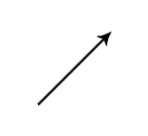 |  | 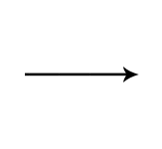
Expressing movement: nouns and verbs
For each trend there are a number of verbs and nouns to express the movement. We can use a verb of change, for example:
Unemployment levels fell
Or we can use a related noun, for example:
There was a fall in unemployment levels
Direction | Verbs | Nouns
 | Rose (to)  Increased (to)  Went up (to)  Climbed (to)  Boomed | A rise  An increase  Growth  An upward trend  A boom (a dramatic rise)
 | Fell (to)  Declined (to)  Decreased (to)  Dipped (to)  Dropped (to)  Went down (to)  Slumped (to)  Reduced (to) | A decrease  A decline  A fall  A drop  A slump (a dramatic fall)  A reduction
 | Levelled out (at)  Did not change  Remained stable (at)  Remained steady (at)  Stayed constant (at)  Maintained the same level | A levelling out  No change
 | Fluctuated (around)  Peaked (at)  Plateaued (at)  Stood at (we use this phrase to focus on a particular point, before we mention the movement, for example:  In the first year, unemployment stood at … ) | A fluctuation  Reached a peak (of)  Reached at plateau (at)
Describing the movement: adjectives and adverbs
Sometimes we need to give more information about a trend as follows:
There has been a slight increase in the value of the dollar (degree of change)
Unemployment fell rapidly last year (the speed of change)
Remember that we modify a noun with an adjective (a slight increase) and a verb with an adverb (to increase slightly).
Describing the degree of change
Adjectives | Adverbs
dramatic | dramatically
sharp | sharply
huge
enormous | enormously
steep | steeply
substantial | substantially
considerable | considerably
significant | significantly
marked | markedly
moderate | moderately
slight | slightly
small
minimal | minimally
Describing the speed of change
Adjectives | Adverbs
rapid | rapidly
quick | quickly
swift | swiftly
sudden | suddenly
steady | steadily
gradual | gradually
slow | slowly

Exercise 1

Use the following terms and any others necessary to describe the graph below.
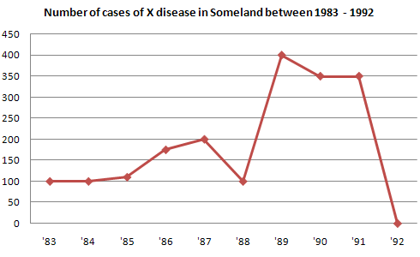
initially, stood at, dip/dipped, peak/peaked, level/levelled out

We can describe a trend by looking at:
- the difference between two levels
- the end point of the trend
Describing the difference between two levels
This year unemployment has increased by 20,000 cases (the difference between this year and last year is 20,000 cases).
This year there has been an increase in unemployment of 5%.
Notice the prepositions. We use to increase by (with the verb) and an increase of (with the noun).
Describing the end point
This year unemployment has risen to 10% (the end result is that unemployment is up to 10%).
This year there has been a rise in unemployment to 10%.
Notice the prepositions. We use to rise to (with the verb) and a rise to (with the noun).

Exercise 2

Write 3 sentences describing the graph below using by, of and to.
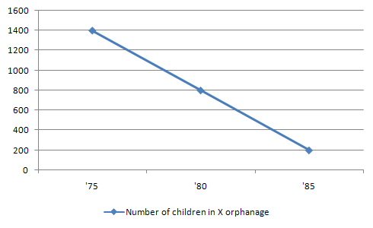
Expressing approximation
We use words to express approximation when the point we are trying to describe is between milestones on the graph.
just under | well under | roughly | approximately
about | just over | well over | nearly

